Project Design Phase-II Technology Stack (Architecture & Stack)

|  |  |
| --- | --- |
| Date | 20th June, 2025 |
| Team ID | Team - LTVIP2025TMID32421 |
| Project Name | TrafficTelligence : Advanced Traffic Volume Estimation with Machine Learning |
| Maximum Marks | 4 Marks |

**Technical Architecture:**

The Deliverable shall include the architectural diagram as below and the information as per the table1 & table 2

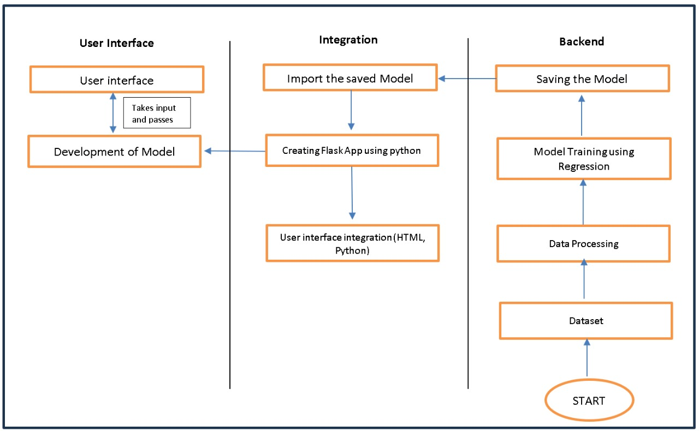

**Table-1 : Components & Technologies:**

|  |  |  |  |
| --- | --- | --- | --- |
| **S.No** | **Component** | **Description** | **Technology** |
| 1. | User Interface | Critical element designed for both Traffic Managers and everyday users, ensuring an intuitive and informative experience. | HTML, CSS, JavaScript |
| 2. | Application Logic-1 | Involves a robust backend system responsible for processing, analyzing, and managing traffic data. | Python |
| 3. | Database | Involves the storage and management of diverse traffic data for analysis. | File Manager, csv |
| 4. | File Storage/ Data | Involves managing diverse types of data, including raw traffic data, machine learning models, and configuration files. | Local System, Google Drive |
| 5. | Frame Work | It is a crucial part of our program as it is responsible for connecting the frontend with the backend. | Python Flask |
| 6. | Machine Learning Model | The machine learning model is responsible for predicting future outcomes based on available data | Machine learning model created using regression algorithms |
| 7. | Infrastructure (Server / Cloud) | Involves a combination of servers and cloud services to support the computational and storage needs of the application. | Local |

**Table-2: Application Characteristics:**

|  |  |  |  |
| --- | --- | --- | --- |
| **S.No** | **Characteristics** | **Description** | **Technology** |
| 1. | Open-Source Frameworks | Open-source frameworks can accelerate development and ensure the reliability of TrafficTelligence, contributing to a more efficient and maintainable solution. | Python’s Flask |

|  |  |  |  |
| --- | --- | --- | --- |
| **S.No** | **Characteristics** | **Description** | **Technology** |
| **2.** | Scalability | Using cameras to collect data and to make models for specific locations. | Computer vision, dynamic databases. |
| 3. | Performance | Regular performance testing, monitoring, and optimization are integral components of the development and maintenance processes, ensuring that TrafficTelligence consistently delivers timely and efficient traffic volume estimations. | R squared, Root mean squared error, Root Mean Square deviation |
| 4. | Availability | Website can be made available all time in a webserver. This makes the website running without any issues | High speed Linux based webservers. |